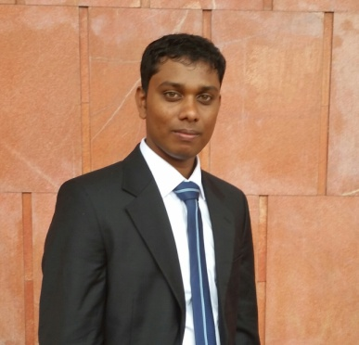

Mr.Chandramohan Pirashanth

Puloly,

Jaffna.

Professional objective

To obtain a respective career, be a leading professional in the field of Quantity Surveying, add value to the organization I work using my knowledge, problem solving skills and professional skills. Career objective is to excel as an individual who can guide a team to perform above their potential and exceed shareholder expectation in relevant field.

Personal details

Name in Full : Chandramohan Pirashanth **Nationality** : Sri Lankan Tamil

Date of Birth : 16th of September 1991 Gender : Male

N.I.C. No : 912602419V Civil Status : Single

Working Experience

* Currently working as a Surveyor in UNOPS Project at Mannar. (working experience for 2 years with UNOPS drainage and Building project)

Educational Qualification

* G.C.E. Advanced Level Examination in 2010

School Attended: J/Hartely College, Point Pedro

Chemistry S

Mathematics S

Physics S

* G.C.E Ordinary Level Examination in 2007 December

School Attended: J/Hartely College, Point Pedro

4 A,3 B, 2 C, S

Professional Qualification

* HND in Quantity Surveying, at BCAS, Colombo.
* Auto CADD

Language Skills

* I have sound knowledge in English & Tamil (Speaking, Writing and Reading).
* I have fair spoken knowledge in Sinhala.

Other Skills and Abilities

* Very high analytical & problem solving skills.
* Knowledge gained in IT & software literacy in Microsoft Office, 2008 and Diploma in Desktop publishing and Diploma in Internet technology by Asian, 2010.
* Can work under high pressure environment.
* Can travel anyplace for gaining experience
* I am familiarized with some of the latest versions of common software packages and comfortably work with the following;
* Computer typing in English and Tamil (40 WPM)
* Microsoft Office 2003 ,2007& 2010 (Word, Excel, Access & Power point)

Projects

* Conducting Drainage project of UNOPS, Mannar.
* Conducted Building construction of school, of UNOPS Project, Mulankavil, Killinochi.

Referees

**Mr. Srirangarajah Thangarajah,**

Mr. Anutharshan Pooranachandran,

Civil Engineer,

UNOPS,

Mannar

Mobile: 0770456941

E-mail: anutharshan@gmail.com

**Technical Officer,**

**UNOPS,**

**Mannar.**

Mobile: 0771325990

E-mail: srirangarajah@yahoo.com

I do hereby certify that the above particulars given by me are true & accurate to the best of my knowledge.

C. Pirashanth

01.07.2015